|  |  |  |  |  |  |
| --- | --- | --- | --- | --- | --- |
| # | Call | Name | RPTR | Signal Check | Traffic |
| 1 | W8DSF | DONNY | SB | + | No Traffic |
| 2 | W7YU | KEITH | AP | - | No Traffic |
| 3 |  |  |  |  |  |
| 4 |  |  |  |  |  |
| 5 |  |  |  |  |  |
| 6 |  |  |  |  |  |
| 7 |  |  |  |  |  |
| 8 |  |  |  |  |  |
| 9 |  |  |  |  |  |
| 10 |  |  |  |  |  |

**Good Morning,** this is **NOVEMBER 9 ZULU ECHO DELTA - N9ZED** acting as **WHISKEY 7 CHARLIE ROMEO TANGO - W7CRT** for the **Thursday, March 20, 2025** Daisy Mountain Fire & Medical CERT Comms Net. The purpose of the net is for licensed amateur radio operators to test and maintain their equipment so that they can be an asset if a situation calls for their skills and services. Secondarily we seek to provide a level of awareness of conditions local to Arizona that may require those services. Before beginning the check ins, if there are any stations with emergency or priority traffic, please call now.

**<< W7CRT Breaking for Traffic >>**

As a reminder this net is open to the public and all licensed amateur radio operators are welcome to join the net even if you are just listening in. We will begin check ins in groups of three at this time.

Please key up, wait one second to allow the repeater systems to connect and slowly present at writing speed:

* Your call sign - phonetically
* Your Name
* The Repeater you are tuned to

**Once Check-Ins are completed. Request Traffic for the Net and document on the Check In Log.**

**Situational Awareness as of** (“Alt+Shift+T”) **6:00 am MST**

**Ready Set Go – Red Yellow Green**

There are NO Red Yellow Green Emergency Bulletins to report at this time.

Data Sourced from <https://ein.az.gov/>

**Weather**

**In the Daisy Mountain Fire District**

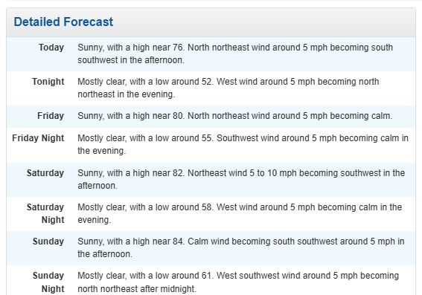

Sandbags are available at Daisy Mountain Station 141, 143, 146.

Data sourced from <https://www.weather.gov/>

**<< W7CRT Breaking for Traffic >>**

**Solar**

Solar Events - There were 5 solar events in the last 24 hours.

Solar Flare Activity - Chance of C-Class, M-class, and X-class Events Today:

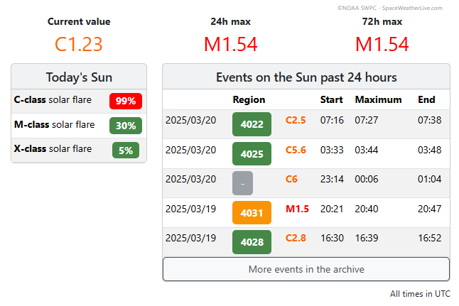

Three (3) Day Forecast:

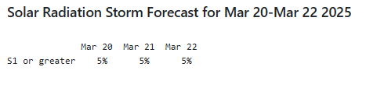

* <https://www.spaceweatherlive.com/en/reports/3-day-forecast.html>

Data sourced from:

* <https://www.spaceweatherlive.com/>
* <https://www.spaceweatherlive.com/en/solar-activity/solar-flares.html>
* <https://www.spaceweatherlive.com/en/reports/3-day-forecast.html>

**Power Outages**

**APS**

* APS reports no major outages at this time

**SRP**

* SRP Reports no major outages as of 6:00 am

**Nationwide**

* **85k**
* **Nebraska 50k**
* **Michigan 25.6k**
* **Arkansas 10k**

Data Sourced from

* <https://www.aps.com/en/Utility/Outage/Outage-Center/Report-Outage>
* <https://myaccount.srpnet.com/power/myaccount/outages>
* <https://poweroutage.us/>

**<< W7CRT Breaking for Traffic >>**

**Seismic Activity**

Normal and unremarkable

* 4 earthquakes recorded in Alaska exceeding 5.0 magnitude in the last 24 hours

Data sourced from:

* <https://www.usgs.gov/programs/earthquake-hazards/earthquakes>
* <https://www.usgs.gov/programs/earthquake-hazards>

**Egress / Ingress**

I17 Southbound Exit Ramp Closed to W Anthem Way, March 21, ending March 22.

I17 – Road Work at 101 and I17

Otherwise, be sure to check your favorite traffic App before leaving home this weekend.

Data Sourced from <https://az511.gov/>

**Cyber Security**

**Excessive Service Interruptions reported on X and Microsoft on March 19th.**

No Major system issues reported

On March 19th, CISA added three (3) new vulnerabilities to its Known Exploited Vulnerabilities Catalog based on evidence of active exploitation. Please check the CISA.gov website for specific information.

This data was sourced from

* [Downdetector.com](https://downdetector.com/) (Use your Cell Phone)
* <https://www.cisa.gov/news-events/cybersecurity-advisories>

**<< W7CRT Breaking for Traffic >>**

**Upcoming Deployments:**

Daisy Mountain Fire & Medical Citizen Corps CERT completed a G-317 Basic Course on March 9th. We are planning our next Course in June. Check the Website and Social Medica for details on the dates.

Anthem Days is happening on March 22nd and 23rd. DMFM Citizen Corps will be providing first aid services and distributing information on preparing for disasters.

* DMFM Citizen Corps Comms Team will be demonstrating amateur radio capabilities including HF, UHF, and VHF.

**Anthem Community Council Touch-a-Truck Details**

April 5, 2025  
9 am to 1 pm (Sensory Hour 9 am-10 am)  
Community Park Softball field #3

This family-friendly event will feature an impressive lineup of first responders, organizations, and industry leaders, all eager to display their latest vehicles and technology.

**Acknowledgements and Adjournments**

We would like to thank the Arizona Repeater Association for allowing W7CRT use of the Metro Link / Rim Link Repeater System for the purpose of conducting our net this morning. Wishing everyone a safe remainder of their week and a fantastic weekend. Stay sharp and we’ll see you back here next week at 0700. We now return the Repeater System to its Regular Use and Traffic.

This concludes Situational Awareness as of 0600 MST **Thursday, March 20, 2025**.